**ANNOUNCING THE SENNHEISER X MASSDROP HD 58X JUBILEE**

***New exclusive headphone pays homage to a classic***

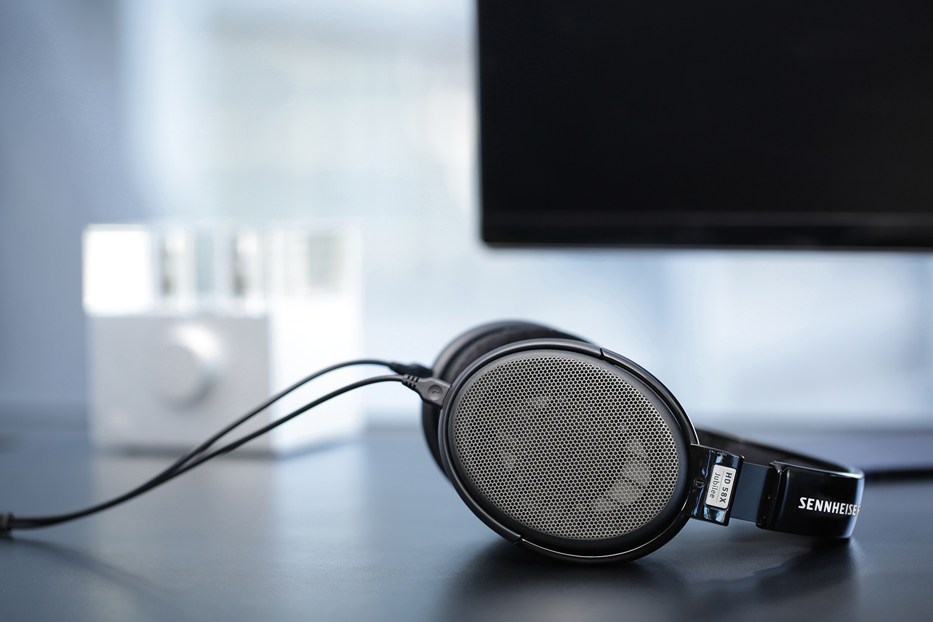**Old Lyme, CT, June 27, 2018 – Audio specialist Sennheiser and Massdrop, a community-driven commerce platform, announced the latest result of the companies’ ongoing partnership: the Massdrop x Sennheiser HD 58X Jubilee. The new exclusive headphone is a tribute to the Sennheiser HD 580 Jubilee, an open, dynamic headphone that helped pave the way for a successful range of audiophile headphones including the HD 600 and the HD 650. This recent cooperation between the two companies follows the success of the Massdrop x Sennheiser HD 6XX, launched in 2016 to the audiophile enthusiast community.**

The HD 58X Jubilee contains design elements of the original Sennheiser HD 580 Jubilee, while incorporating a brand-new transducer and 150-ohm drivers — which require less amplification than previous driver platforms. This provides increased versatility, so listeners can experience reference-class fidelity while using either stationary or mobile playback devices.

“In Sennheiser, we have found a partner who is listening to our community and is able to respond quickly to input we receive,” commented Steve El-Hage, CEO and Co-Founder of Massdrop. “The design and sound signature of the HD 58X Jubilee were crafted based on this direct feedback, enabling Massdrop to quickly deliver on exactly what the enthusiast community is asking for.”

**Harkening a 25-year-old classic**

The sound signature of the Sennheiser HD 58X Jubilee can be described as clear, fast, dynamic and lively, sharing similar characteristics with the Sennheiser HD 600 and the HD 650 headphones. A clean, extended bass response is combined with a smooth and clear upper midrange.

In an aesthetic homage to the Sennheiser HD 580 Precision headphone, the HD 58X Jubilee features a glossy black headband and gray metal grilles. The headband is generously padded, and the ear pads are covered in soft velour for hours of comfortable listening. The accompanying detachable 6-foot cable is made of highly conductive OFC copper with sturdy para-aramid reinforcement and a very low handling noise.

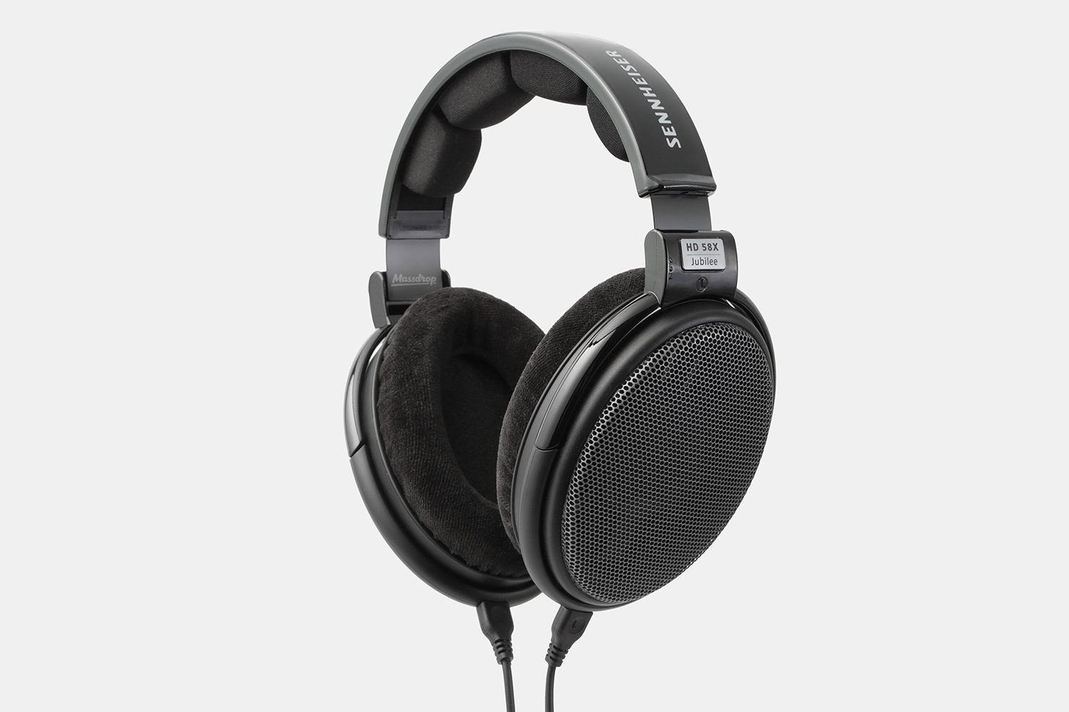“I joined Sennheiser in 1991 as a Development Engineer, and my very first product was the HD 598,” recalls Axel Grell, Head of Portfolio Management Audiophile, Sennheiser. “This was the beginning of our audiophile collection and set the standard in the field of audiophile headphone technology. I am honored by the passion and interest the Massdrop community maintains in our product line, and I am happy to see the HD 58X come to life for the enjoyment of a new generation of audiophiles.”

The new Massdrop x Sennheiser HD 58X Jubilee headphone will be offered on Massdrop’s website at an introductory price of $150, and will launch on Wednesday, June 27th at 6 a.m. Pacific Time and ship in 2 to 3 business days.

**Specifications**

• Massdrop x Sennheiser

• Glossy black headband, gray metal grilles

• Ear coupling: Over-ear (circumaural)

• Transducer principle: Open, dynamic

• Impedance: 150 ohms

• Frequency response: 12–38,500 Hz (-10 dB)

• THD + N: < 0.1% at 1 kHz, 100 dB

• Sound pressure level: 104 dB at 1V, 1 kHz

• Connector: ⅛ in (3.5 mm) gold-plated stereo jack plug

• Cable: 6 ft (1.8 m) OFC, detachable

• Weight without cable: Approx. 9.2 oz (260 g)

• Individually serialized

• Made in Ireland

**About Massdrop**

Massdrop is an online community for enthusiasts. Whether you're an audiophile, quilter, backpacker, or style maven, you can connect with others, discuss your interests and favorite products, and save on those products when you buy together. Founded in 2012 by Steve El-Hage and Nelson Wu, the company now serves more than 2 million monthly users. To learn more visit massdrop.com.

**About Sennheiser**  
Shaping the future of audio and creating unique sound experiences for customers – this aim unites Sennheiser employees and partners worldwide. Founded in 1945, Sennheiser is one of the world’s leading manufacturers of headphones, microphones and wireless transmission systems. With 21 sales subsidiaries and long-established trading partners, the company is active in more than 50 countries and operates its own production facilities in Germany, Ireland, Romania and the USA. Since 2013, Sennheiser has been managed by Daniel Sennheiser and Dr. Andreas Sennheiser, the third generation of the family to run the company. In 2017, the Sennheiser Group generated turnover totaling €667.7 million.

**Regional Press Contact**

Hummingbird Media, Inc.

Jeff Touzeau

T: +1 (914) 602-2913

jeff@hummingbirdmedia.com

**Global Press Contact**

Sennheiser electronic GmbH & Co. KG

Jacqueline Gusmag

T: +49 (0)5130 600-1540

jacqueline.gusmag@sennheiser.com